How can I change the wireless channel and security mode?
Sometimes, you may need to change the wireless channel or/and security mode when you meet some wireless connectivity issues. This article will guide you on changing them in detail.
Part 1: Connect the devices together
Part 2: Log into the web-based setup page
Part 3: Change the wireless channel
Part 4: Change the security mode

Connect the devices together
Step 1:
Take an Ethernet cable to connect your computer with one of the yellow LAN ports of the Tenda device.
Step 2:
Ensure that the light corresponding to the LAN port where the Ethernet cable is connected to is lit. If it is lit, you may proceed with the next procedure. Otherwise, try to connect your computer to another yellow LAN port or change another Ethernet cable.
Note: There is only one LAN or LAN/WAN port on some devices like A5/A6/A3/A30/N3/3G150B/PW201A, etc. You can only log into the setup page wirelessly for A5 and 3G186R.

Log into the web-based setup page
Find out the login IP address on the label located on the back of the Tenda device, and then enter it in the address bar of a web browser. Enter the login username and password if prompted, generally admin both for username and password. If you have ever changed the login IP address or password, you should login with the new IP address and password.
You may need to refer to the User Guide for help about logging into the setup page. For troubleshooting on logging into the setup page, click here.
Note: For A5 and 3G186R, you can only log into the setup page wirelessly.

Change the wireless channel
Tips on finding the best channel:
i. You can download a tool like inSSIDer to analyze, which will show you the wireless channels nearby networks are using and recommend the ideal channel for you to use — one that isn’t being used by so many networks.
ii. If you don’t have access to a wireless-analyzing app, you can simply try a different channel and then see if the wireless connection improves. Begin with channel 1 and 6, then 11, if all of those are slow, try others. For instructions on changing the channel, click here.
Follow the steps below to change the channel:
Step 1:
Click on Advanced Settings/Advanced directly after logging into the setup page.
Step 2:
Select Wireless Settings/WLAN Settings/Wireless from the main menu.
Step 3:
Select Wireless Basic Settings/Basic Settings/Basic from the submenu and you will then be directed to a page similar to the one below.
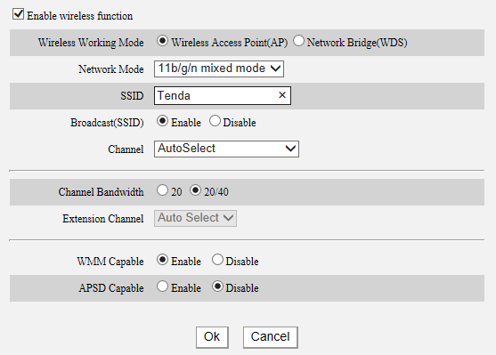
Step 4:
Locate the Channel and choose a channel from the drop-down menu. Click on OK/Apply/Save.
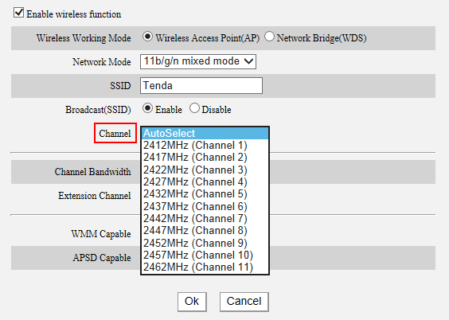

Change the security mode
It is highly recommended to use WPA or WPA2 personal as wireless security modes. Other than providing better security, this will establish a more stable connection with your wireless device, especially devices with the latest technology.
Step 1:
Click on Advanced Settings/Advanced directly after logging into the setup page.
Step 2:
Select Wireless Settings/WLAN Settings/Wireless from the main menu.
Step 3:
Select Wireless Security/Security Settings/Security from the submenu, you will be directed to a page similar to the one below.
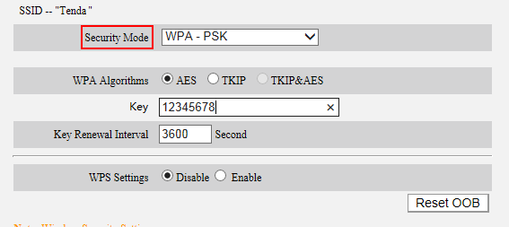
Step 4:
Locate the Security Mode (also called Network Authentication) and you can change the security mode there. For a Tenda device, you can select WPA-PSK, WPA2-PSK, Mixed WPA/WPA2-PSK, WPA Personal, WPA2 Personal or Mixed WPA-WPA2 Personal.
Note: You’d better select AES as the WPA-Algorithms/Cypher Type/WPA Encryption.
Sometimes, the wireless security mode of the Tenda device is not compatible with your wireless device. You may need to disable the wireless security. This is especially true for older devices and Windows Vista computers. You can secure your Wi-Fi with Access Control once the security mode is disabled, click here for instructions.

